**Cross Platform C4 Diagram**

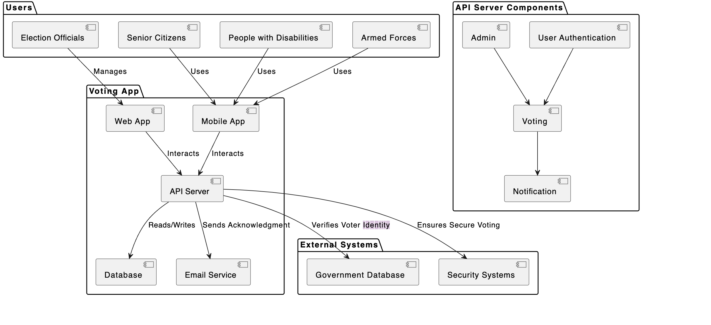

By- 2021hs70039

Tulika Sen Gupta